Quarterly Report – Public Page

Date of Report: 11th Quarterly Report- June 27, 2025
Contract Number: 693JK32210002POTA
Prepared for: Government Agency: DOT and Co-funders
Project Title: Monitoring the Long-Term Compatibility of Vapor Corrosion Inhibitor and Cathodic Protection Associated Components
Prepared by: Pipeline Research Council International, Inc.
Contact Information: Janie Norton, email: jnorton@prci.org
For quarterly period ending: June 30, 2025

1: Items Completed During this Quarterly Period:

Item # | Task # | Activity/Deliverable | Title | Federal Cost | Cost Share
36 | 2 | Finish field testing for the tanks where VCI will be injected during the project duration, and pre- and post-VCI data will be collected | Summary of findings to be included in quarterly report | $19,545 | $19,545
37 | 3 | Finish collecting data related to VCI plus CP compatibility issue, analyze data and derive results | Summary of findings to be included in quarterly report | $13,030 | $13,030
38 | 5 | Quarterly status report & project management | Submit 10th quarterly report | $4,249 | $4,249

2: Items Not Completed During this Quarterly Period:

Item # | Task # | Activity/Deliverable | Title | Federal Cost | Cost Share
30 | 2 | Finish large-scale control experiments to determine VCI dispersion range, collect and analyze data | Summary of the data to be included in the quarterly report | $19,545 | $19,545

3: Project Financial Tracking During this Quarterly Period:

Note that this chart reflects Federal share only.
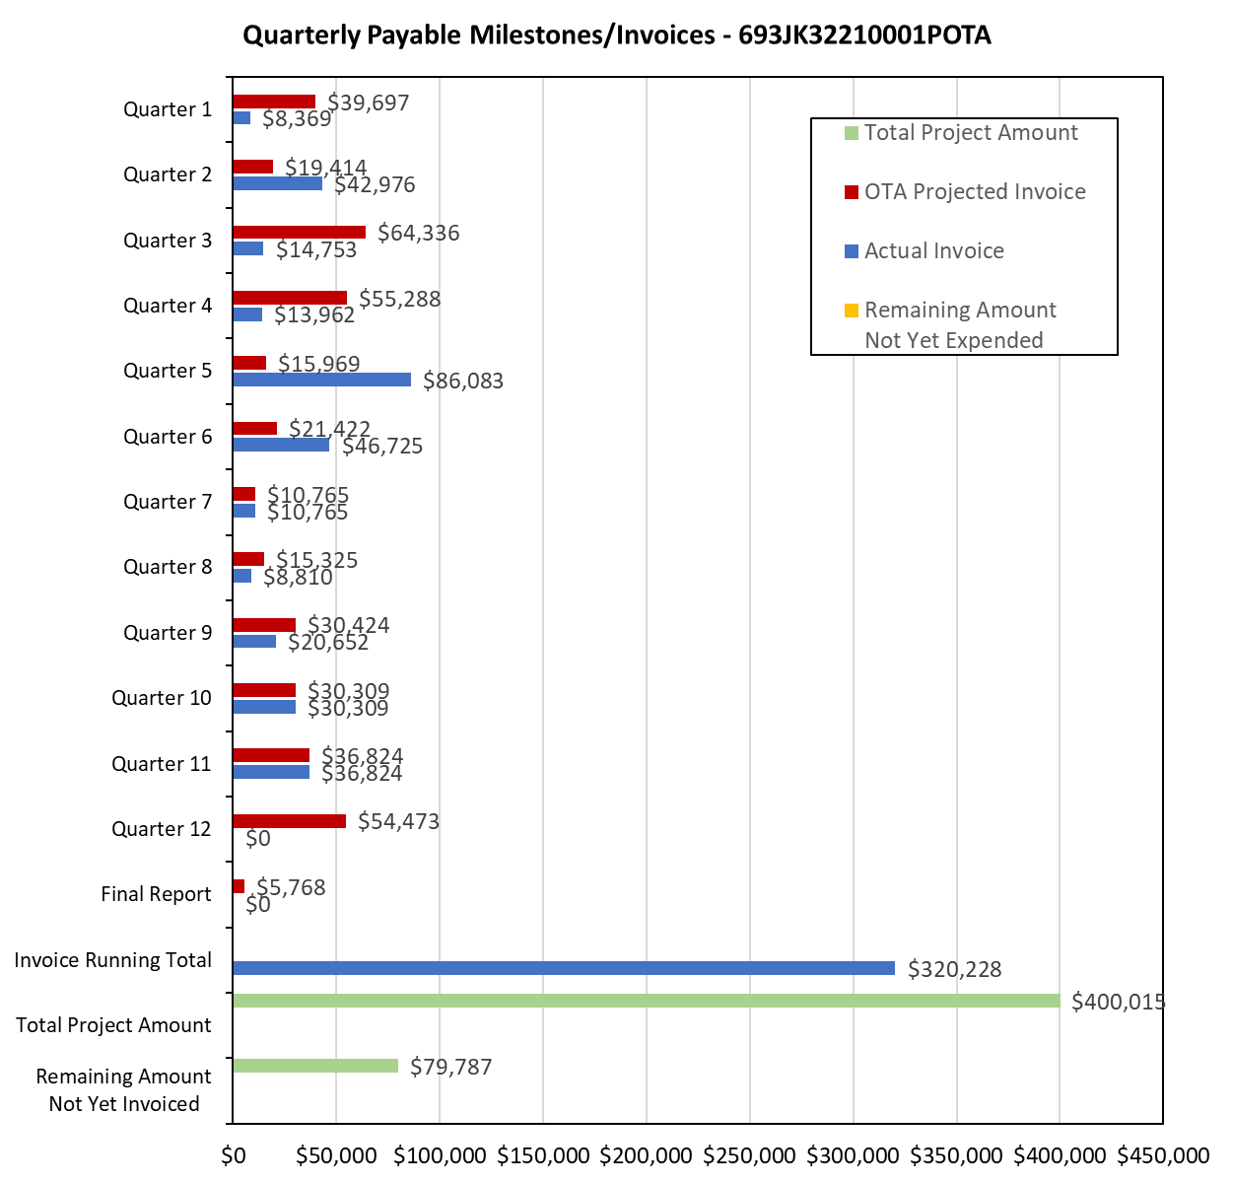

4: Project Technical Status:

Item 36, Task 2 ⎯ Finish field testing for the tanks where VCI will be injected during the project duration, and pre- and post-VCI data will be collected. Summary of findings to be included in quarterly report. Five tanks were treated with VCI during this project. However, pre-VCI monitoring data was not available because the monitoring was not installed during the VCI injection, and not before. However, the sand samples were collected immediately prior to VCI injection; therefore, sand chloride levels are used to estimate the sand pad corrosivity. The UT-based mass-loss coupons were installed when the VCI injections were made. The chloride levels in the sand samples are also listed in Table 1; the chloride levels are used to estimate the pre-VCI corrosivity of the tank sandpad. As listed in Table 1, the chloride-based corrosivity of the tank samples if high, and monitoring data indicate that the corrosivity was suppressed post VCI.

Table 1. Corrosion Monitoring Data and Chloride Level Analysis of the VCI-Treated Tanks During the Project Course
Tank ID | UT-Coupon Based Monitoring Corrosion Rate (mpy) | Chloride Level (ppm) | Chloride Level Based Estimated Corrosivity (mpy) | Notes
Tank 1 | 0.5, 0.9, 1.7, 1.0 | 20-40 | 3-7 | High chloride levels, the monitoring data indicate that corrosivity is suppressed with VCI injection.
Tank 2 | 0.0, 1.5, 2.2, 0.9 | > 40 | > 5 | ibid
Tank 3 | 0.0, 0.1, 0.0, 0.0 | 30-40 | 3-7 | ibid
Tank 4 | 0.3, 0.4, 0.5, 0.5 | 20-40+ | 3-7 | ibid
Tank 5 | 0.0, 0.0, 0.0, 0.0 | 3-25 | 2-4 | Slightly lower chloride levels than the previous four tanks, the monitoring data indicate that corrosivity is completely suppressed with VCI injection.

This activity links to item 7 as listed in Attachment 1 Team Project Activities. This activity also satisfies item 23 in Attachment 2 Project Deliverables.

Item 37, Task 3 ⎯ Finish collecting data related to VCI plus CP compatibility issue, analyze data and derive results, Summary of findings to be included in quarterly report.

The rectifier current output and groundbed resistance data for the six tanks, which were included in the PRCI Phase 2 work, before and after VCI is presented in Figures 1 and 2, respectively; two additional years of data was added under the current project. In addition, data was six additional tanks become available under this project; the rectifier current output and groundbed resistance data for the additional six tanks are presented in Figures 3 and 4, respectively.

A decrease in the rectifier output data would indicate an adverse effect of the VCIs on the anode performance. Similarly, a large change in the ground bed resistance data would indicate change in the resistivity of the sand pad. The rectifier output data indicate in Figure 1 indicate that there are no specific trends after addition of the VCIs, the same is observed in the groundbed resistance data in Figure 2, i.e., there are no specific trends before and after addition of the VCIs. And analysis of the data in Figures 3 and 4 also affirmed that trends in the rectifier current output and groundbed resistance cannot be attributed to the VCI addition. In summary, it is determined that addition of the VCI does not adversely affect the anode and groundbed resistance for the VCI treated tanks with existing CP systems.

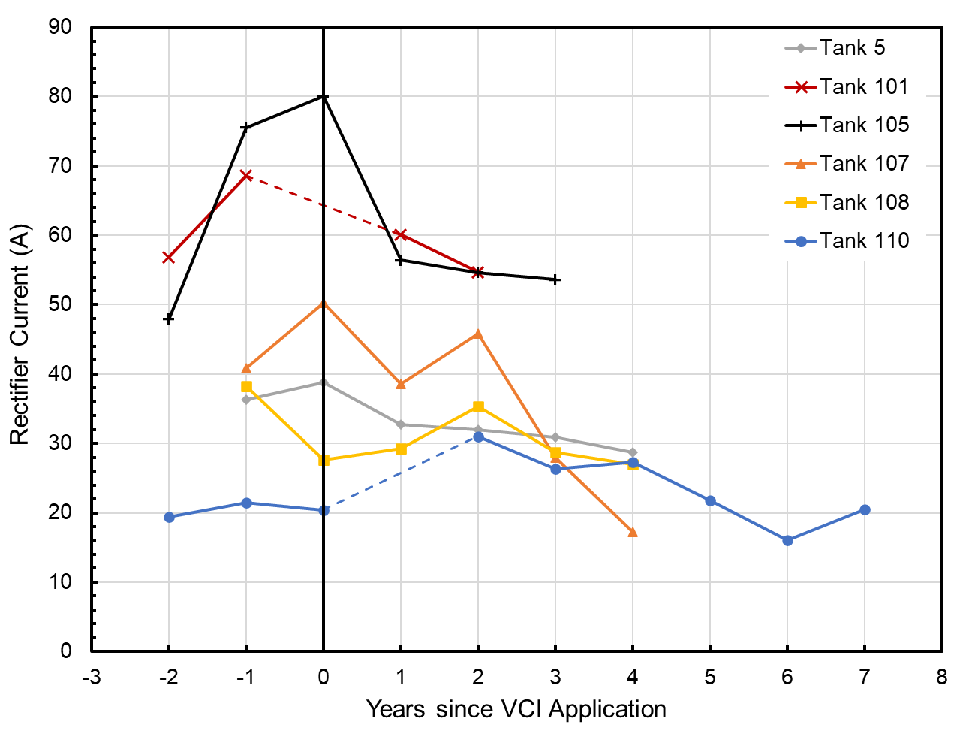 | 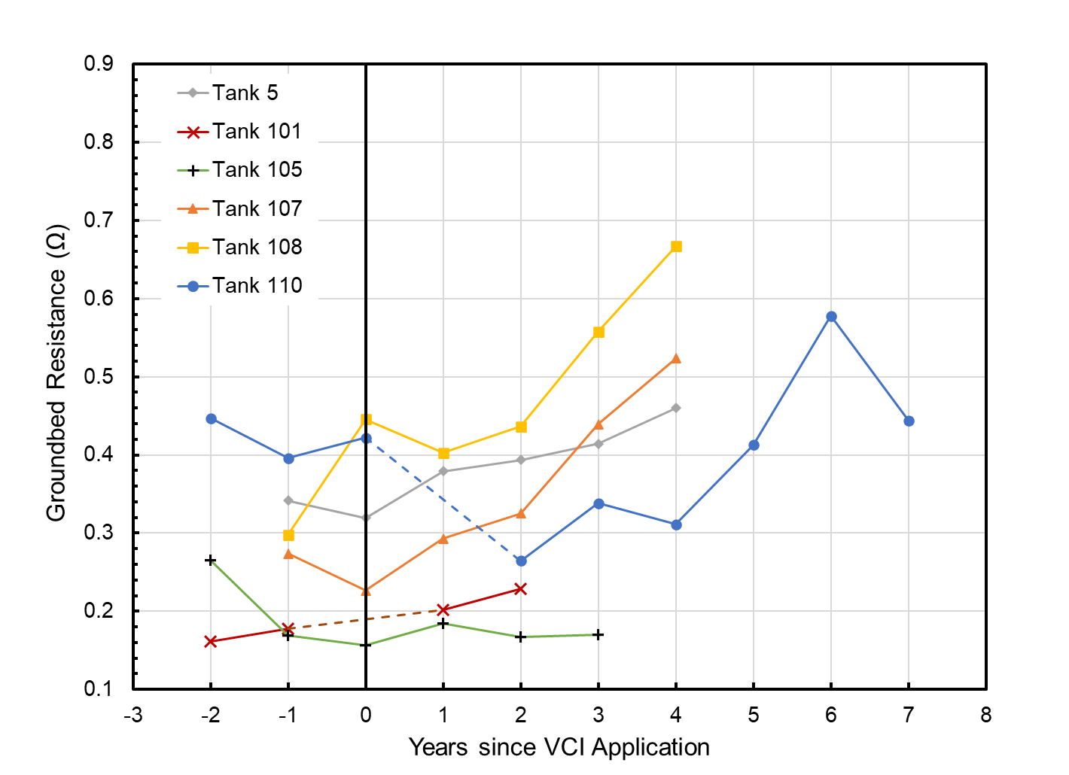
Figure 1. Rectifier current output data for six tanks. These six tanks were studied in PRCI Phase 2 work and two additional years of data was added under this project. | Figure 1. Groundbed resistance data for six tanks. These six tanks were studied in PRCI Phase 2 work and two additional years of data was added under this project.
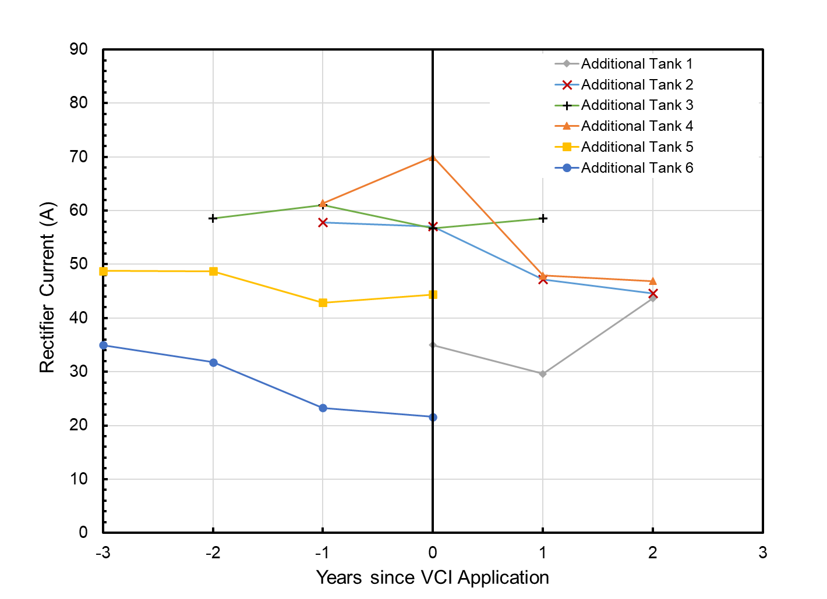 | 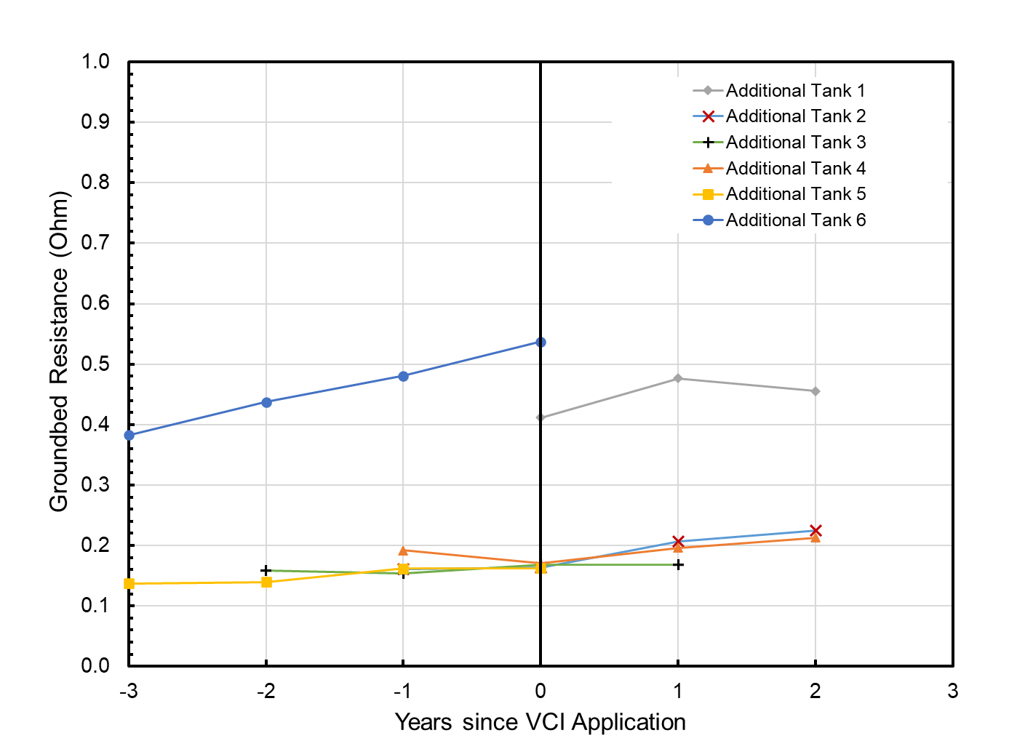
Figure 3. Rectifier current output data for six additional tanks. The data for these tanks became available under the current project. | Figure 4. Groundbed resistance data for six additional tanks. The data for these tanks became available under the current project.

This activity links to item 8 as listed in Attachment 1 Team Project Activities. This activity also satisfies item 24 in Attachment 2 Project Deliverables.

Item 38, Task 5 ⎯ Quarterly status report & project management. Submit 11th quarterly report: The 11th quarter project meeting was held on June 12, 2025. This item has been completed, and it partly satisfies item 25 in Attachment 2 Project Deliverables. It also links to item 13 as listed in Attachment 1 Team Project Activities. The quarterly meeting link to item 11 as listed in Attachment 1 Team Project Activities.

5: Project Schedule:

Item 30, Task 2 ⎯ Finish large-scale control experiments to determine VCI dispersion range, collect and analyze data. Summary of the data to be included in the quarterly report: Of the two large-scale experiments, one is still on-going. The second large-scale experiment will be finished in the first week of July 2025. The post-VCI treated coupons will be extracted and analyzed.

Overall, the project is behind schedule, a six-month no-cost extension has been submitted and awaiting approval.

